**University of Petroleum and Energy Studies**

School of Computer Science

Department of Cybernetics

**Graphics & Animation Tools**

**LAB FILE**

**(Session: 2020-2021)**

Course: B. Tech with Specialization in Open Source and Open Standards

Submitted To- Submitted By-

Dr. Durgansh Sharma Kunal Ojha

Associate Professor SAP ID -500063333

Department of Cybernetics Roll No. -R100217034

**Experiment 1-** Installation of GIMP AND BLENDER.

**GIMP version 2.10.20 Installation steps-**

1. Download the setup from <https://www.gimp.org/>

2. Run the setup from your pc the first dialog box is as shown below Click on ok after selecting the language of your choice.

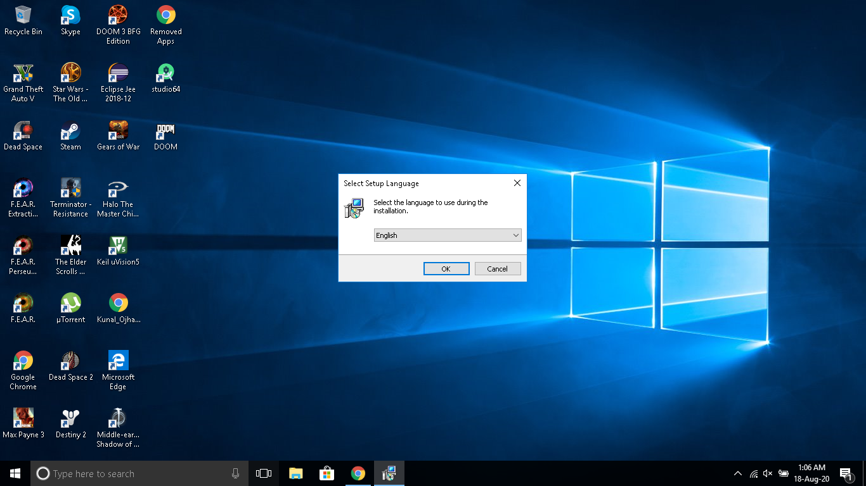

3. The main dialog box opens as shown below three buttons are present click on install if you simply want to install in the standard way or click on customize if you want a custom installation.

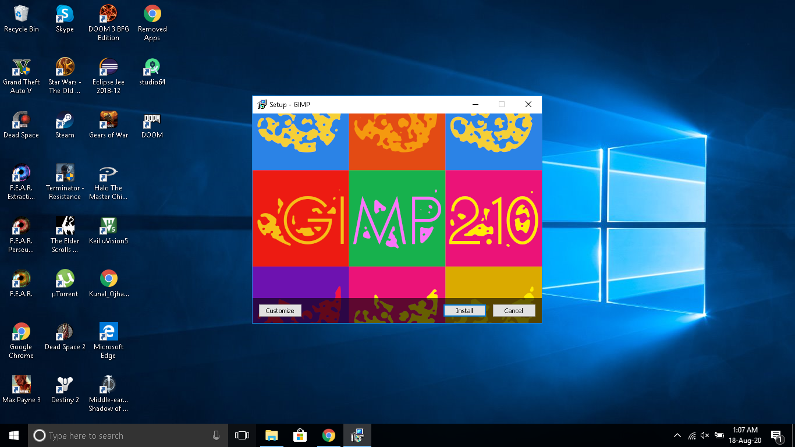

4.After clicking on customize the following screen appears to accept the license click on next.

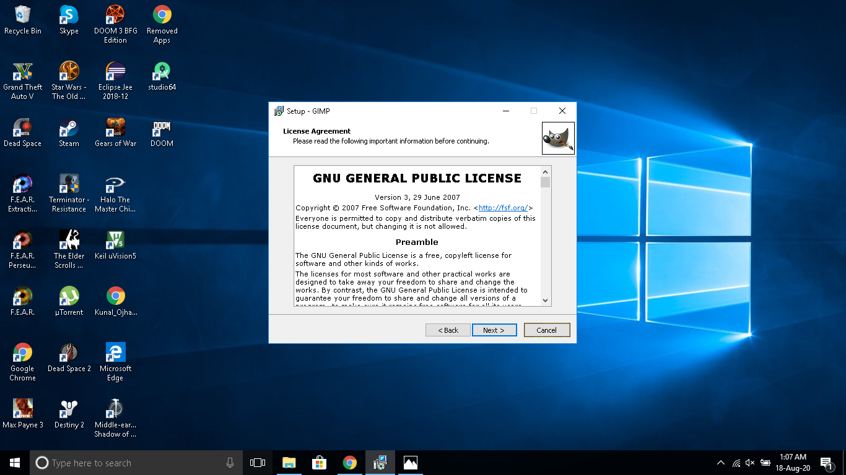

5. Select the installation directory and click on next.

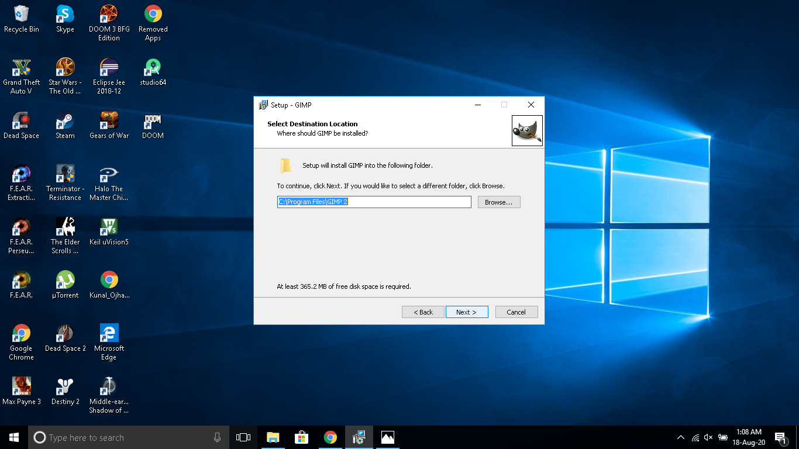

6. Select full installation to install all features of GIMP and click on next

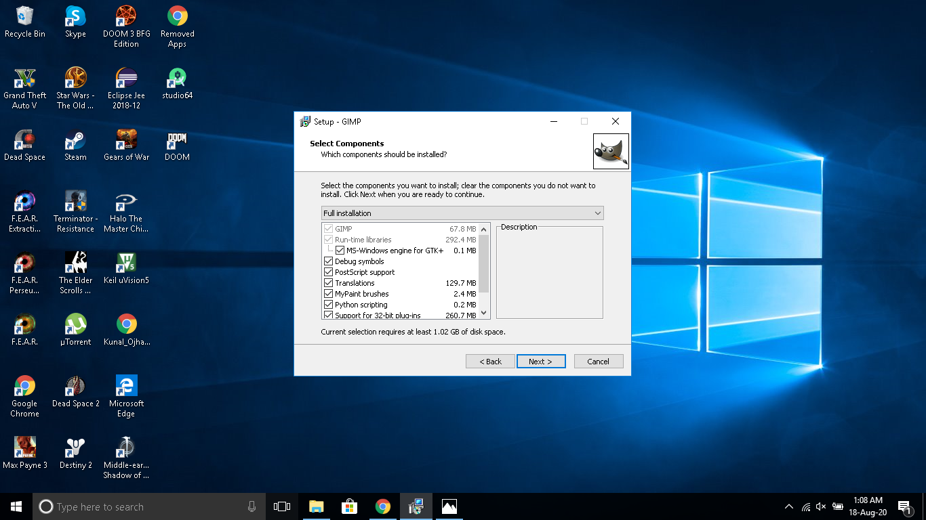

7. Click on the create desktop icon checkbox and click on next to begin installation.

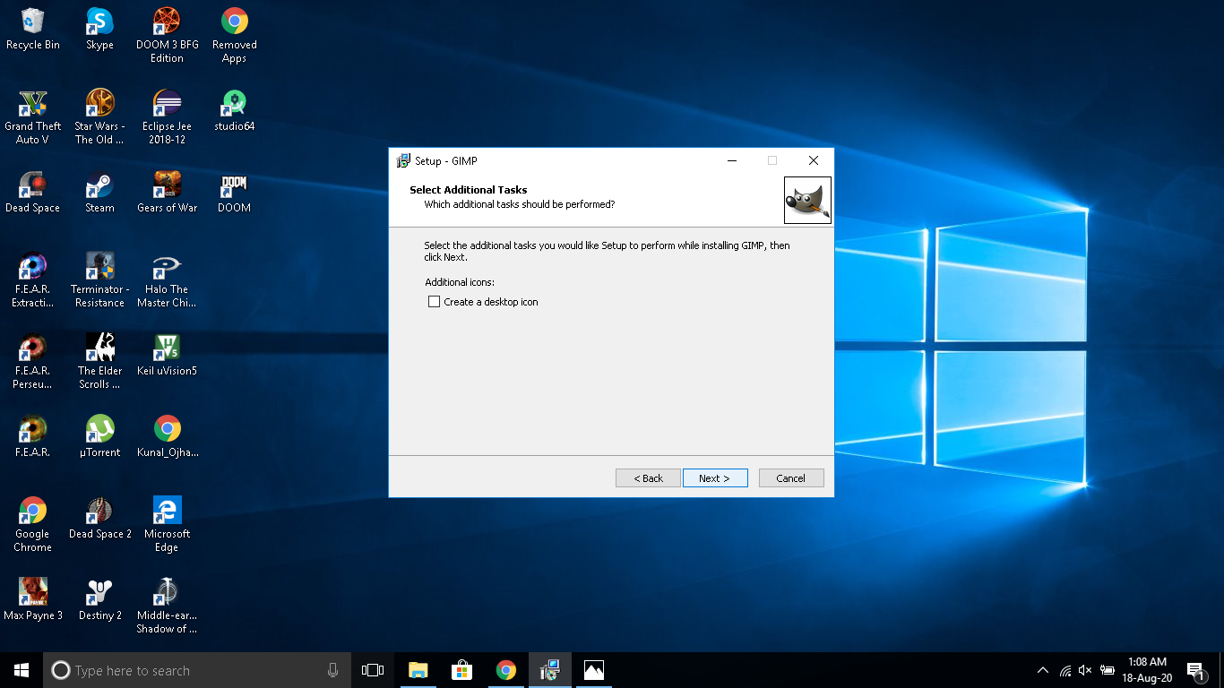

8.Let the installation complete and click on finish to exit setup.

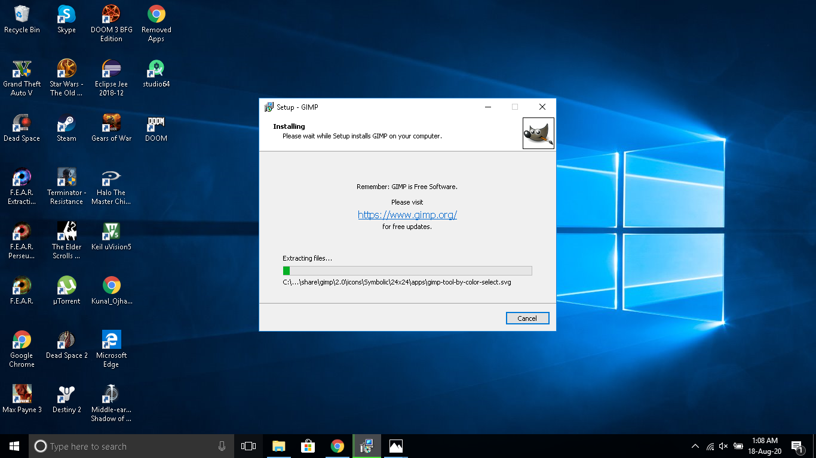

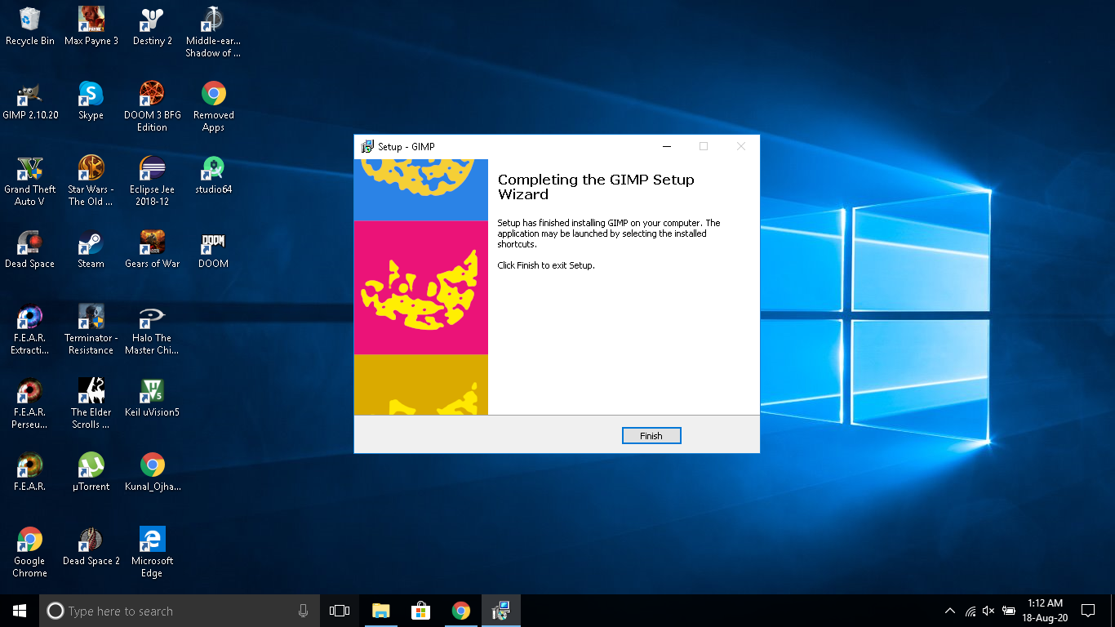

**Blender version 2.8.3.0 Installation steps-**

1. Download the setup from https://www.blender.org/download/

2. Run the setup from your pc the main dialog box opens as shown below click on next to proceed with installation.

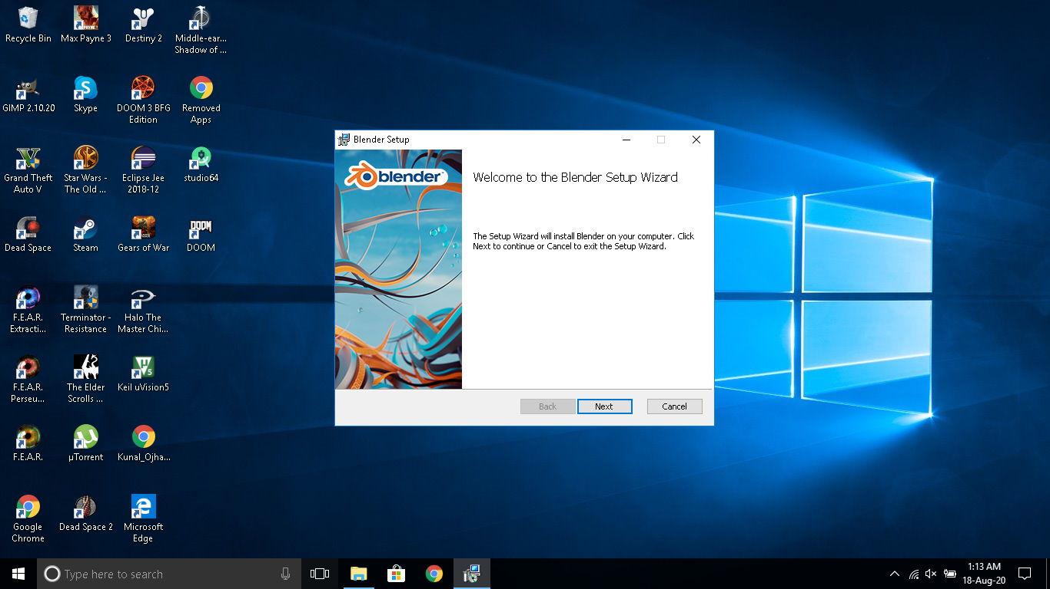

3. After clicking on next the following screen appears, to accept the license click on checkbox and on next.

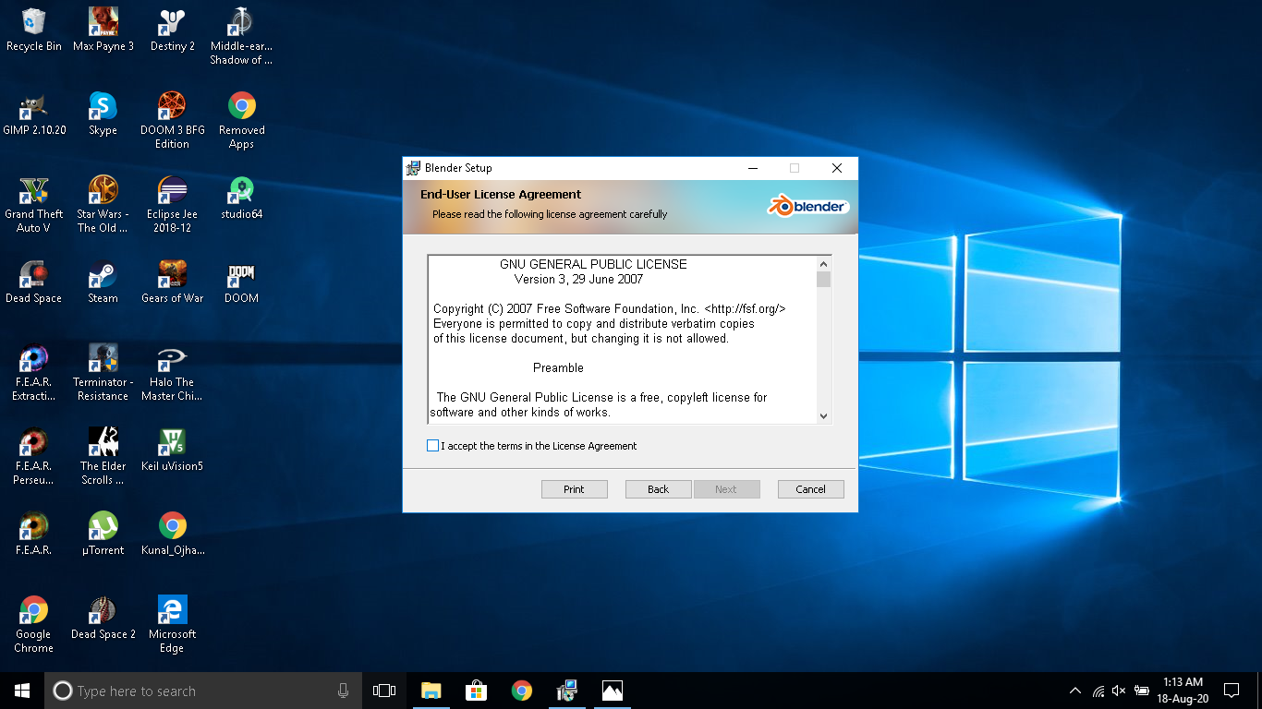

4. Select the installation directory and click on next.

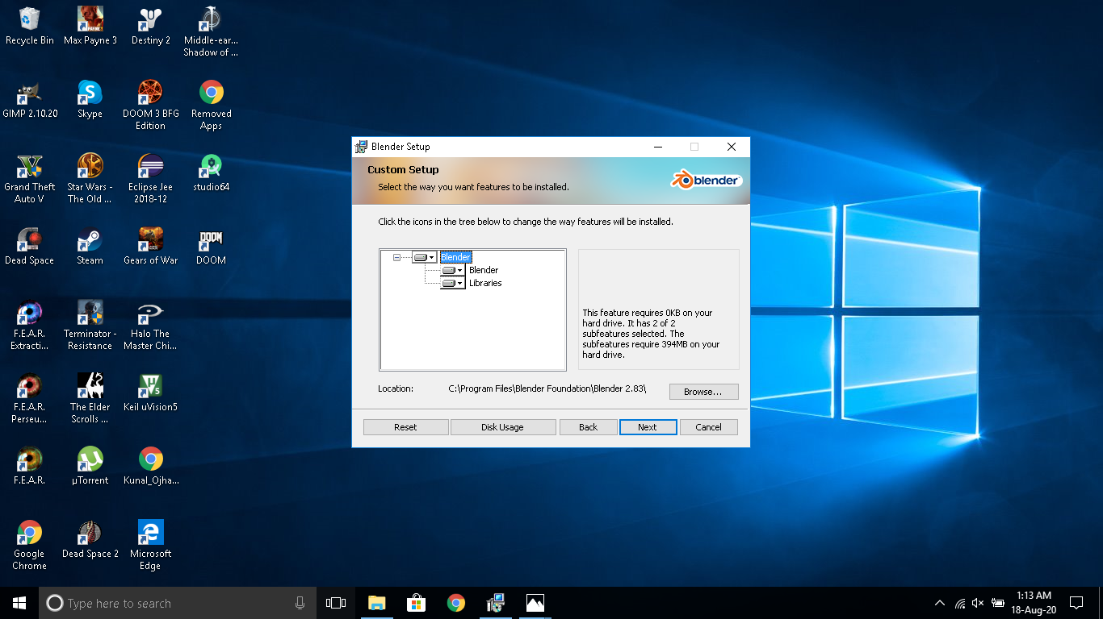

5. Click on install to begin installation.

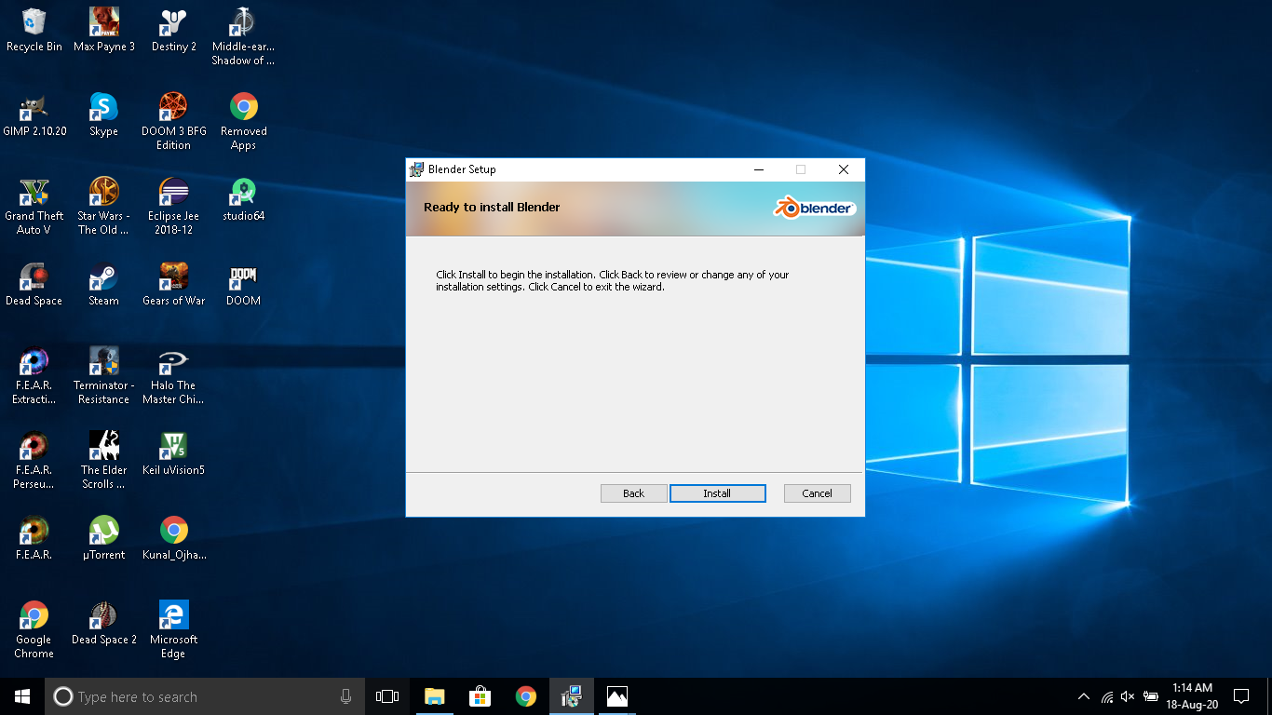

6.Let the installation complete and click on finish to exit setup.

